**API specification——视频播放**

members：窦锦涛 ID:16301085

厉欣林 ID:16301096

our group using videoview api to finish the video play.

**the package dependency**



the implement:

Create the UI:

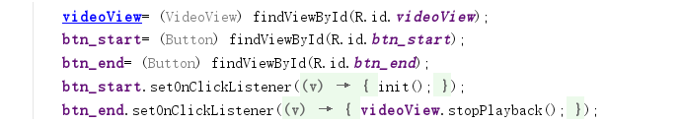

Main implement：

